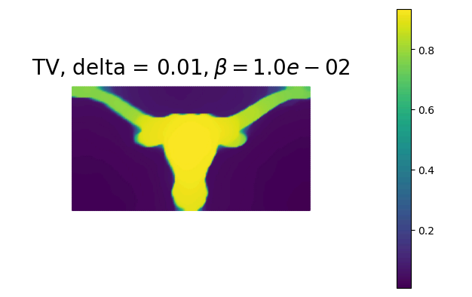
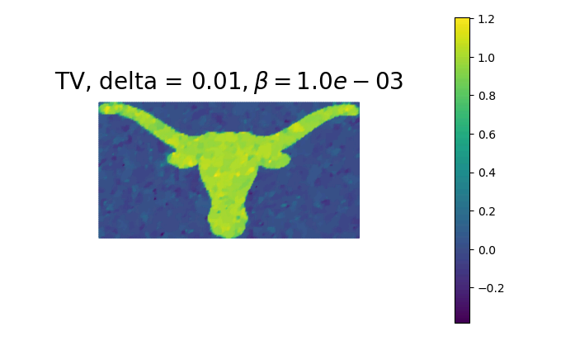
Some select regularization constants and their corresponding outputs are shown below:
The above graph is the optimal solution (ideal amount of total variation regularization), per visual inspection and the L-curve (shown below).
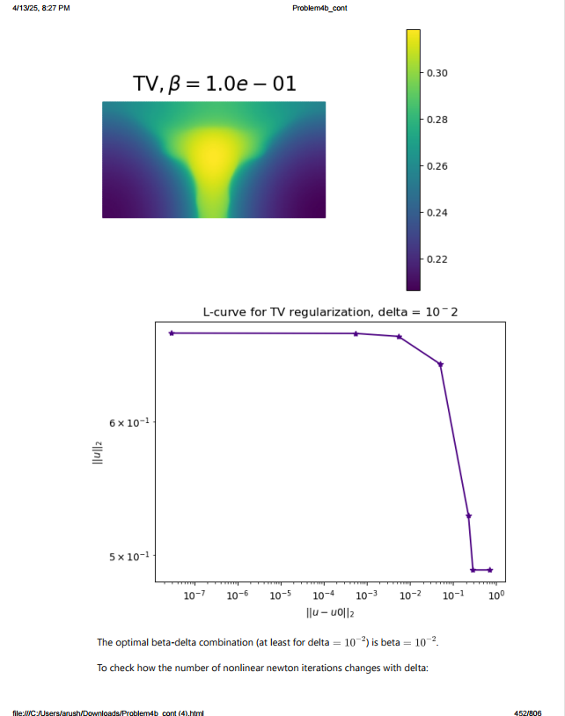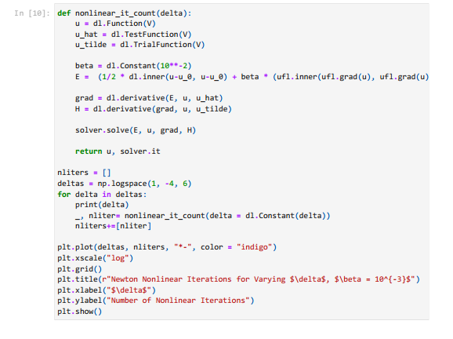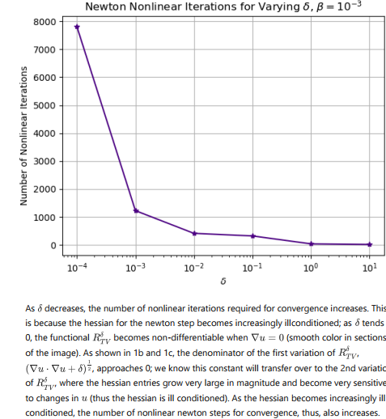

Note in the above graph, beta equals 10**-2, not 10**-3; there is a typo here.
